SEC Form 4
FORM 4 |  | UNITED STATES SECURITIES AND EXCHANGE COMMISSION  Washington, D.C. 20549  STATEMENT OF CHANGES IN BENEFICIAL OWNERSHIP  Filed pursuant to Section 16(a) of the Securities Exchange Act of 1934  or Section 30(h) of the Investment Company Act of 1940
  OMB APPROVAL
  OMB Number: | 3235-0287
  Estimated average burden
  hours per response: | 0.5
 | Check this box if no longer subject to Section 16. Form 4 or Form 5 obligations may continue. See Instruction 1(b).
 | Check this box to indicate that a transaction was made pursuant to a contract, instruction or written plan for the purchase or sale of equity securities of the issuer that is intended to satisfy the affirmative defense conditions of Rule 10b5-1(c). See Instruction 10.
1. Name and Address of Reporting Person*  (Street) | 2. Issuer Name and Ticker or Trading Symbol  AGCO CORP /DE [ AGCO ] | 5. Relationship of Reporting Person(s) to Issuer  (Check all applicable)
  Audia Damon J
  (Last) | (First) | (Middle)
  4205 RIVER GREEN PARKWAY
  DULUTH | GA | 30096
  (City) | (State) | (Zip)
   | Director |  | 10% Owner
   | Officer (give title below) |  | Other (specify below)
  SVP, Chief Financial Officer
3. Date of Earliest Transaction (Month/Day/Year)
07/14/2026
 | 4. If Amendment, Date of Original Filed (Month/Day/Year) | 6. Individual or Joint/Group Filing (Check Applicable Line)
  Form filed by One Reporting Person
  Form filed by More than One Reporting Person
Table I - Non-Derivative Securities Acquired, Disposed of, or Beneficially Owned
1. Title of Security (Instr. 3) | 2. Transaction Date (Month/Day/Year) | 2A. Deemed Execution Date, if any (Month/Day/Year) | 3. Transaction Code (Instr. 8) |  | 4. Securities Acquired (A) or Disposed Of (D) (Instr. 3, 4 and 5) |  |  | 5. Amount of Securities Beneficially Owned Following Reported Transaction(s) (Instr. 3 and 4) | 6. Ownership Form: Direct (D) or Indirect (I) (Instr. 4) | 7. Nature of Indirect Beneficial Ownership (Instr. 4)
1. Title of Security (Instr. 3) | 2. Transaction Date (Month/Day/Year) | 2A. Deemed Execution Date, if any (Month/Day/Year) | Code | V | Amount | (A) or (D) | Price |  | 6. Ownership Form: Direct (D) or Indirect (I) (Instr. 4) | 7. Nature of Indirect Beneficial Ownership (Instr. 4)
Common Stock | 07/14/2026 |  | A |  | 145.559 | A | $107.73 | 50,475.559(1) | D
Table II - Derivative Securities Acquired, Disposed of, or Beneficially Owned
(e.g., puts, calls, warrants, options, convertible securities)
1. Title of Derivative Security (Instr. 3) | 2. Conversion or Exercise Price of Derivative Security | 3. Transaction Date (Month/Day/Year) | 3A. Deemed Execution Date, if any (Month/Day/Year) | 4. Transaction Code (Instr. 8) |  | 5. Number of Derivative Securities Acquired (A) or Disposed of (D) (Instr. 3, 4 and 5) |  | 6. Date Exercisable and Expiration Date (Month/Day/Year) |  | 7. Title and Amount of Securities Underlying Derivative Security (Instr. 3 and 4) |  | 8. Price of Derivative Security (Instr. 5) | 9. Number of derivative Securities Beneficially Owned Following Reported Transaction(s) (Instr. 4) | 10. Ownership Form: Direct (D) or Indirect (I) (Instr. 4) | 11. Nature of Indirect Beneficial Ownership (Instr. 4)
 |  |  |  | Code | V | (A) | (D) | Date Exercisable | Expiration Date | Title | Amount or Number of Shares
Explanation of Responses:
1. Includes 145.559 shares of Common Stock acquired by the reporting person as a result of participating in the AGCO Corporation Employee Stock Purchase Plan.
Remarks:
 | /s/ Kinsha O. Swain Attorney-in-Fact | 07/16/2026
 | ** Signature of Reporting Person | Date
Reminder: Report on a separate line for each class of securities beneficially owned directly or indirectly.
* If the form is filed by more than one reporting person, see Instruction 4 (b)(v).
** Intentional misstatements or omissions of facts constitute Federal Criminal Violations See 18 U.S.C. 1001 and 15 U.S.C. 78ff(a).
Note: File three copies of this Form, one of which must be manually signed. If space is insufficient, see Instruction 6 for procedure.
Persons who respond to the collection of information contained in this form are not required to respond unless the form displays a currently valid OMB Number.
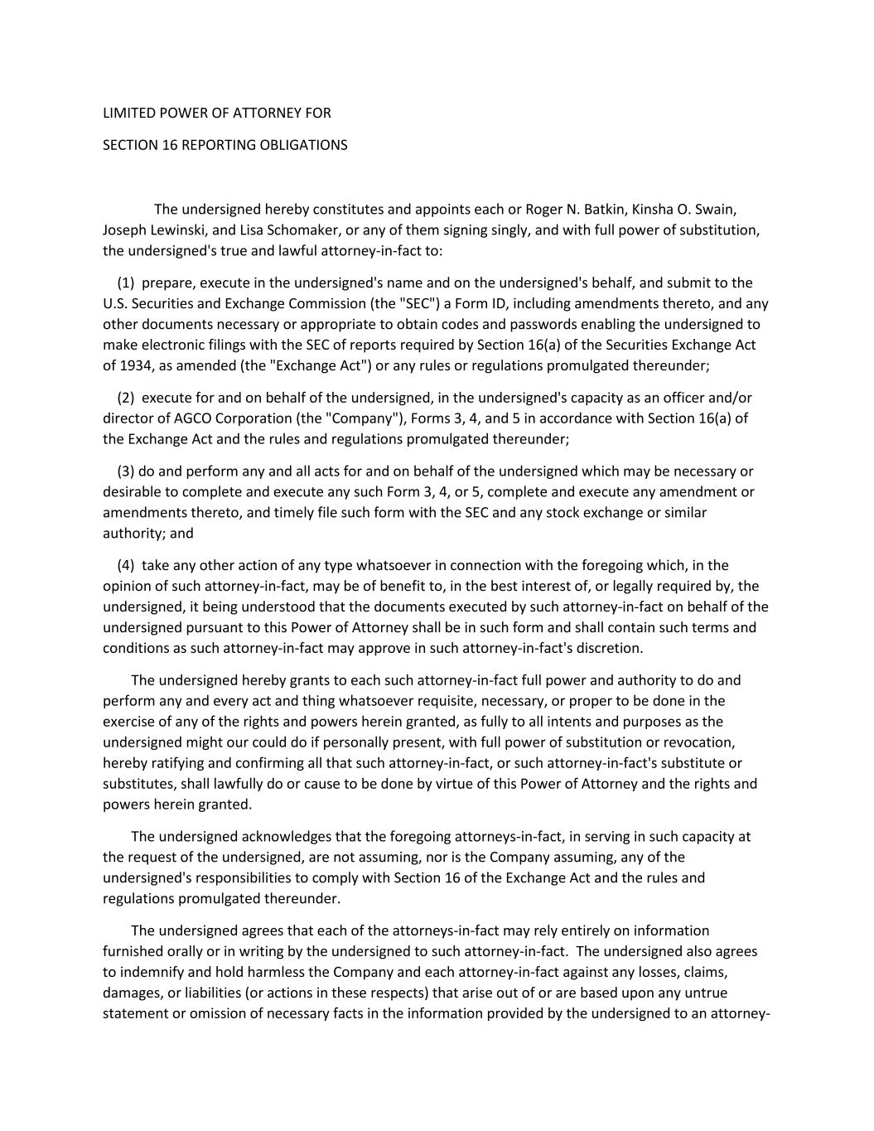
LIMITED POWER OF ATTORNEY FOR SECTION 16 REPORTING OBLIGATIONS The undersigned hereby constitutes and appoints each or Roger N. Batkin, Kinsha O. Swain, Joseph Lewinski, and Lisa Schomaker, or any of them signing singly, and with full power of substitution, the undersigned's true and lawful attorney-in-fact to: (1) prepare, execute in the undersigned's name and on the undersigned's behalf, and submit to the U.S. Securities and Exchange Commission (the "SEC") a Form ID, including amendments thereto, and any other documents necessary or appropriate to obtain codes and passwords enabling the undersigned to make electronic filings with the SEC of reports required by Section 16(a) of the Securities Exchange Act of 1934, as amended (the "Exchange Act") or any rules or regulations promulgated thereunder; (2) execute for and on behalf of the undersigned, in the undersigned's capacity as an officer and/or director of AGCO Corporation (the "Company"), Forms 3, 4, and 5 in accordance with Section 16(a) of the Exchange Act and the rules and regulations promulgated thereunder; (3) do and perform any and all acts for and on behalf of the undersigned which may be necessary or desirable to complete and execute any such Form 3, 4, or 5, complete and execute any amendment or amendments thereto, and timely file such form with the SEC and any stock exchange or similar authority; and (4) take any other action of any type whatsoever in connection with the foregoing which, in the opinion of such attorney-in-fact, may be of benefit to, in the best interest of, or legally required by, the undersigned, it being understood that the documents executed by such attorney-in-fact on behalf of the undersigned pursuant to this Power of Attorney shall be in such form and shall contain such terms and conditions as such attorney-in-fact may approve in such attorney-in-fact's discretion. The undersigned hereby grants to each such attorney-in-fact full power and authority to do and perform any and every act and thing whatsoever requisite, necessary, or proper to be done in the exercise of any of the rights and powers herein granted, as fully to all intents and purposes as the undersigned might our could do if personally present, with full power of substitution or revocation, hereby ratifying and confirming all that such attorney-in-fact, or such attorney-in-fact's substitute or substitutes, shall lawfully do or cause to be done by virtue of this Power of Attorney and the rights and powers herein granted. The undersigned acknowledges that the foregoing attorneys-in-fact, in serving in such capacity at the request of the undersigned, are not assuming, nor is the Company assuming, any of the undersigned's responsibilities to comply with Section 16 of the Exchange Act and the rules and regulations promulgated thereunder. The undersigned agrees that each of the attorneys-in-fact may rely entirely on information furnished orally or in writing by the undersigned to such attorney-in-fact. The undersigned also agrees to indemnify and hold harmless the Company and each attorney-in-fact against any losses, claims, damages, or liabilities (or actions in these respects) that arise out of or are based upon any untrue statement or omission of necessary facts in the information provided by the undersigned to an attorney-

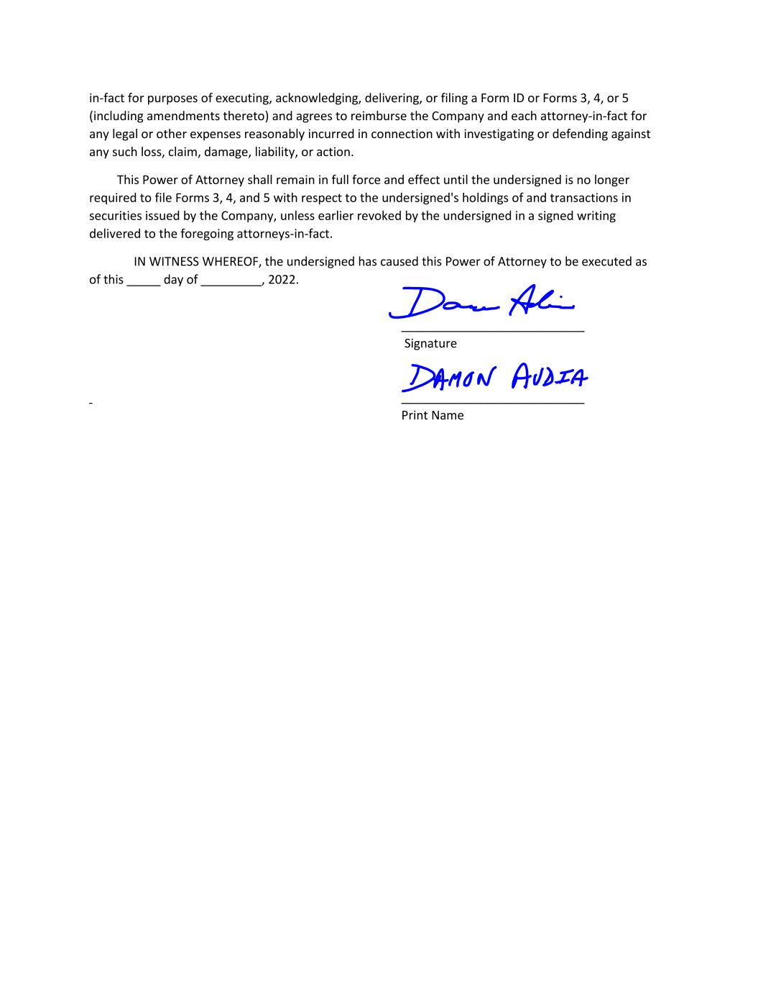
in-fact for purposes of executing, acknowledging, delivering, or filing a Form ID or Forms 3, 4, or 5 (including amendments thereto) and agrees to reimburse the Company and each attorney-in-fact for any legal or other expenses reasonably incurred in connection with investigating or defending against any such loss, claim, damage, liability, or action. This Power of Attorney shall remain in full force and effect until the undersigned is no longer required to file Forms 3, 4, and 5 with respect to the undersigned's holdings of and transactions in securities issued by the Company, unless earlier revoked by the undersigned in a signed writing delivered to the foregoing attorneys-in-fact. IN WITNESS WHEREOF, the undersigned has caused this Power of Attorney to be executed as of this _____ day of _________, 2022. ___________________________ Signature ___________________________ Print Name

